NTNU - Norwegian University of
Science and Technology
Department of Engineering Design
and Materials

EXAMINATION IN COURSE
TMM4230 Technology for Integrated Operations and Semantic Web

Technical contact during the exam: Ole Ivar Sivertsen (97472129), Ole-André Johansen (99460685) and Jon Atle Gulla (91347759).

Phone: 73592541

Date : 2nd of June 2010
Time : 0900 - 1300
Weighting : 7,5

Aids allowed : D: No written or handwritten examination support materials are permitted.
Certain, specified calculator** are permitted.

** "Certain, specified calculator" means a calculator with simple, numerical and trigonometrical functions such as +, -, sine, cosine etc. The type of calculator is to be easy for examination invigilators to recognize.

All tasks are to be answered. Each answer has to be marked with the corresponding task-number and index. The answers must be clearly and nicely written. It will be emphasized that the text is clear and concise. Sketches should be made in such a scale that they are easily understood.

Language : English
Number of pages :
Number of appendix :

To be subjected to censorship by 23rd of June 2010.

Note: Unless specified, select only ONE alternative. If more than one seems plausible, select the most correct one. Most tasks give 1 point for a correct answer, and 0 for a wrong answer, but some give more points and can also give a negative score. This is noted in the task text.

Write the task number and the chosen alternative on your answer sheet. In some of the tasks, you are supposed to write an answer, not only select an alternative. This will be clearly specified in the task.

Part 1 – Microsoft .NET and C#

Task 1.1
What is the purpose of the Common Language Specification?

- Ensure compliance between different .NET languages.
- Make sure a specific language can be compiled to a common assembly using Visual Studio
- Abstract the language specific implementation details from other users of .NET.
- Compile MSIL code in assemblies to machine code when the code is executed.

Task 1.2
What is “boxing”?

- When you have a private variable in a class (a field), that variable is said to be “boxed”
- If you call a method with a reference type parameter, that parameter is “boxed” before it is sent to the method.
- If you assign a value type to a reference type variable, the value type is said to be “boxed” into the reference type.
- Boxing occurs when you use auto-properties in C#.

Task 1.3
What is an assembly, and what does it contain?

- A Visual Studio project file. It contains the information about the project and how it should be assembled.
- A file from the Base Class Library (BCL). It contains methods that can be used by others.
- A collection of source code files in the Assembly language. These are the files that are used by the Common Language Specification.
- A DLL file that is made from compiling C# source code. It contains the MSIL code that is run by the Common Language Runtime, metadata about the code and any resources needed.

Task 1.4
What services are provided by the CLR (Common Language Runtime), as presented in the syllabus?

NOTE: Select all that applies. Every correct mark gives 1 point. Wrong marks give minus 1 point. This means that you should not mark an option if you are not sure that it is correct.

- Managing threads
- C# and VB language JIT compilation
- Documentation
- Memory management
- Exception handling
- Registry cleanup
- Multicore manager
- Code security

Task 1.5
What will the following code print if it is run?

try
{
int myFutureSalary = int.MaxValue;
int raise = 1000;
myFutureSalary += raise;

Console.WriteLine(“win”);
}
catch
{
Console.WriteLine(“fail”);
}

- “win”
- “fail”
- The answer depends on the architecture of the computer (32 or 64 bit)
- The code does not compile and cannot be run; nothing is printed

Task 1.6
What is the purpose of a Namespace?

- To specify what classes should go in what assemblies
- To give a name to your program
- To avoid name collisions
- None of the above

Task 1.7
What is an event?

- A special method on Graphical User Interface (GUI) controls
- A way of getting notified of a given happening
- A branch statement in code. Similar to the switch … case statement
- The only way to know when a class is finished working

Task 1.8
What is the CLR (Common Language Runtime)?

- The core of Visual Studio that is common for running all the .NET languages (C#, VB.NET, F#)
- Central component in the Base Class Library (BCL)
- The engine in the .NET Framework for executing applications on any operating system
- None of the above

Task 1.9
What is a Property in a class?

- A piece of metadata – information about the class that you can specify when writing the class.
- A set of methods that can be used like a class field by clients, but is actually getter and setter methods.
- A property is given in angle brackets “[]” above the class name, and gives information about the class.
- A property is a public field in a class. This exposes information to clients of the class.

Task 1.10
Below on the left is a list of access modifiers that can be applied to classes, methods and so on in .NET. On the right is a list of explanations for the same modifiers. Your task is to match them up correctly.

NOTE: Answer by writing a letter and a number together on your answer sheet, for instance, A2, B1, C3 and so on. Correct match gives 1 point, wrong match gives 0 points. This means that you can try to match every modifier without a point penalty.

- public  - protected  - private  - sealed  - internal  - protected internal | - Only members of exactly this class  - Protected in assembly  - Public access only within assembly  - Only members of class and subclasses may access  - Everyone may call or access  - Can’t use a as a base class

Task 1.11
The class CountdownTimer exposes an event called Elapsed. It is invoked when the given amount of time has elapsed. You have an instance of CountdownTimer called timer and a method called timer_elapsed that you need the timer to call when it elapses. Write the code needed to subscribe to the event on your answer sheet.

Part 2 – Windows Communication Foundation

Task 2.1
What is a Web Service?

- It is a way for companies to expose services to user on the Internet. Facebook is an example of a Web Service.
- It is computer programs for inter-machine communication over a network
- It is a way to get information from a company over the http protocol
- A standard for inter-process communcation in a web server
- It is used to give commands into a web server to alter the behavior of the server

Task 2.2
What is the Windows Communcation Foundation?

- It is a part of the .Net framework that is used for creating Graphical User Interfaces (GUI)
- It is the network part of the .NET framework
- It is a unified plattform for distributed computing using .NET
- It is a class library for Instant Messaging for .NET
- It is the system used by Microsoft to communicate on the Internet

Task 2.3
You are implementing a web service – StockService. The service returns a type that contains price information about a given stock. You have to implement the type StockInfo and the service interface IStockService. The StockInfo class has one string property Name and a float property called CurrentPrice.

Below, the implementation of the service is shown. Your task is to write down the definition of the IStockService interface and the StockInfo class on your answer sheet.
- Remember to add WCF attributes to the service and data contract.
- The Name and CurrentPrice properties should be implemented as C# 3.5 auto-properties:
public string SomeProperty { get; set; }
- IStockService and StockInfo should be public
- StockInfo should not have any explicit constructor.
NOTE: There will be given two points on this task; 1 for the interface definition, and 1 for the class implementation. There is no point penalty for wrong anwers.

namespace StockServices
{
public class StockService : IStockService
{
public StockInfo GetInfo (string stockTicker)
{
return StockInfoProvider.GetInfo(stockTicker);
}
}
}

Task 2.4
What langage is WSDL (Web Service Description Langauge) based on?
- SOA
- WCF
- C#
- XML
- SOAP
- None of the above

Task 2.5
What option below best describes SOAP (Simple Object Access Protocol)?

- A protocol for Instant Messaging
- A wrapper for other messages. It is used to hide the content for others on the network.
- A protocol for sending control messages when objects are exchanged using some other protocol. This is called a out of band protocol.
- A protocol for exchanging information over any medium
- The protocol used for object access in Windows Communication Foundation

Task 2.6
...
<system.serviceModel>
<services>
<service name="OrdbokService.OrdbokService">
<endpoint address="" binding="wsHttpBinding" contract="OrdbokService.IOrdbokService">
<identity>
<dns value="localhost" />
</identity>
</endpoint>
<endpoint address="mex" binding="mexHttpBinding" contract="IMetadataExchange" />
<host>
<baseAddresses>
<add baseAddress="http://localhost:8731/Design_ Time_Addresses/OrdbokService/Service1/" />
</baseAddresses>
</host>
</service>
</services>
</system.serviceModel>
...

The text snippet above is taken from a WCF configuration file. What is the name of the .NET interface that defines the custom operations exposed by this web service?

- Service1
- IMetadataExchange
- IOrdbokService
- wsHttpBinding
- Ordbokservice
- Both b) and c) above
- None of the above

Task 2.7
You are developing a client for the service you implemented in task 2.3. You have a Windows Forms application with a textbox and a button. The textbox is called txtTicker. A ticker is a short name to identify a compony on the stock exchange. For example: STL is the stock ticker of Statoil on Oslo Stock Exchange. The interface for the web service has a single method with the following signature:
StockInfo GetInfo(string stockTicer)
When the user clicks the “Get Price” (btnGetPrice) button, you want the application to invoke (call) the GetInfo method the web service, sending in the stock ticer from the text box (txtTicker) and putting the answer in the variable called info. The stock price information is then showed in a message box.

Below is the code for the click event of btnGetPrice, but some crucial parts have been removed. Complete it by filling in the blanks using the information provided. Write line number and what code you would insert in the blank on your answer sheet.

NOTE: The width/length of the blanks are not representative for the length of the code you may insert. It will be given 1 point per correct line of code, and there is no point penalty for wrong answers.

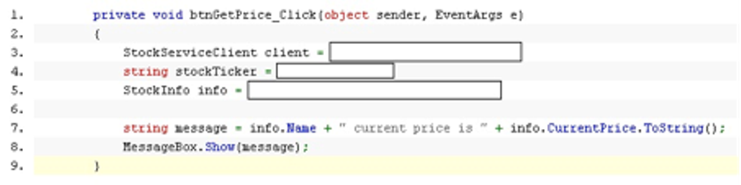

Part 3 – Windows Workflow Foundation

Task 3.1
Windows Workflow foundation (WF) supports two main types of workflows. Which one of them is shown on the figure below? If the figure does not show a WF workflow at all, state this in your answer.

NOTE: Write the answer on you answer sheet. A long explanation receives zero points.

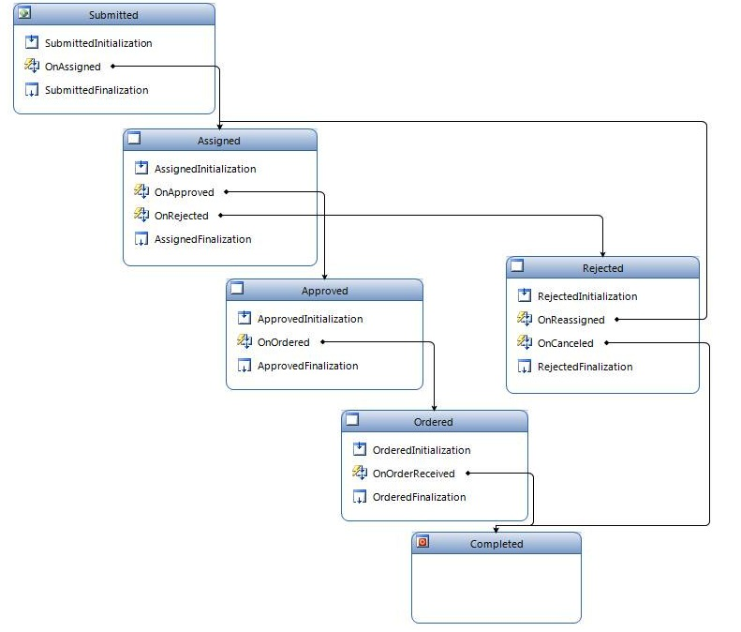

Task 3.2
In state machine workflows, can states be repeated? I.e. can you go from state A to B, then back to A?

- Yes
- No
- Only if the workflow is not defined to be long-lived
- Only if the workflow is a console application

Task 3.3
Write the definition of a Workflow on your answer sheet. The definition should not exceed five lines.

Task 3.4
What is true about Windows Workflow Foundation? (select all that applies)

NOTE: It will be given 1 point for every correct answer, and minus 1 for every wrong answer. This means that you should not mark an option if you are not sure that it is correct.

- Workflows are layed out in a Visual Designer
- The activities you can choose from are limited to the ones that ship with Workflow Foundation
- There are only two types of workflows
- The workflow is not a stand-alone application
- Any workflow can be run by a Runtime Service
- WF is part of .NET 2.0
- The compiled Workflow is executed by the Runtime Engine
- A WF activity is just a normal class

Part 4 – Real Time Communication

Task 4.1
Real time communication is:

- Synchronious, same place
- Asyncronious, same place
- Synchronious, different place
- Asyncronious, different place

Task 4.2
What functions/services does SIP (Session Initiation Protocol) provide? (select all that applies)

NOTE: It will be given 1 point for every correct answer, and minus 1 for every wrong answer. This means that you should not mark an option if you are not sure that it is correct.

- User Interface (displaying call progress to the user)
- Data Transfer (transferring the voice and video data over the network)
- User Capabilities (determines codecs, encryption capabilities etc. of the client devices)
- Voice and video compression (for better utilization of the network)
- Session Management (call transfer, session termination etc.)
- Command line interface (provides command line tools for conversation setup)

Task 4.3
What is VoIP?

- Voice In Person; a system for telepresence
- A system for transmitting volume information about a sound stream, Volume Information Protocol
- Volatile Internet Presence. A protocol for communication over the unstable parts of the Internet
- Voice Over Internet Protocol. A protocol for doing voice communication over the Internet

Task 4.4
What is the responsibility of audio and video codecs?

- Convert the audio or video data into a form that is transmittable over the network.
- Compress and decompress the audio or video data to make it smaller for storage or network transfer.
- Codecs are only used to compress the audio and video data. Descramblers uncompress it.
- A codec is the SIP (Session Initiation Protocol) endpoint on the machine, taking care of sending and receiving SIP messages.
- None of the above.

Part 5 - Introduction to the Semantic Web

Task 5.1
What role does XML play in the Semantic Web?

a) Definition of OWL
b) Serialization of OWL ontology models
c) Unified format for ontology mapping
d) Representation of ontology layout
e) Semantic markup language for the Semantic Web

Task 5.2
What is an ontology?

a) Description of a language for defining domain models
b) Abstract description of commonly accepted phenomena of a domain
c) Set of principles for application interoperability
d) Domain experts’ tacit knowledge of the domain

Task 5.3
We often distinguish between top-level ontologies, application ontologies, domain ontologies and task ontologies. Which type of ontology is the most likely to change?

a) Top-level ontologies
b) Application ontologies
c) Domain ontologies
d) Task ontologies

Task 5.4
What does URI stand for?

a) Unique Role Identification
b) Uniform Resource Identifiers
c) Unmarked Record Interoperability
d) Unified Resource Integration

Task 5.5
What is the purpose of namespaces in the Semantic Web?

a) namespaces are shorthand notations for URIrefs
b) a namespace identifies a particular resource
c) namespaces specify rules for naming resources
d) namespaces associated with URIrefs disambiguate duplicate element names.

Part 6 - Ontology languages

Task 6.1
What is a property in RDF?

a) URI reference
b) The type of a resource
c) Mapping from RDF resources to OWL classes
d) Binary relation between subjects and objects

Task 6.2
What is not supported in RDF or RDFS?

a) Cardinality constraints
b) Classes
c) Definition of subclasses
d) Definition of range of properties

Task 6.3
What is the type property used for in RDF?

a) Defining a resource as an instance of a class
b) Defining subclass relationships
c) Defining a resource as a specialization of another resource
d) Defining an alias for a resource
e) Defining a label for a resource

Task 6.4
Which is the most expressive language that retains computational completeness and decidability?

a) XML
b) RDF
c) RDFS
d) OWL DL
e) OWL Full

Task 6.5 (2 points)
What is the essential difference between open world and closed world assumption?

Part 7 - OWL Modeling

Task 7.1
What is topmost class in OWL

a) Thing
b) Object
c) Resource
d) Element
e) There is no fixed topmost class in OWL

Task 7.2
What are the most important modeling primitives in OWL

a) Resources, relations and attributes
b) Classes, properties and individuals
c) Classes and resources
d) Objects, types and properties
e) Subjects, objects and properties

Task 7.3
What is not true about classes in OWL?

a) All classes may have instances
b) Instances of superclasses are always instances of the class
c) Instances of subclasses are always instances of the class
d) OWL classes are subclasses of RDF classes

Task 7.4
What is the formal interpretation of a class in OWL DL?

a) set of OWL statements describing the class
b) set of instances of the class
c) set of resources in RDF
d) set of objects in the interpretation domain
e) set of object pairs in the interpretation domain

Task 7.5
What is the formal interpretation of a property in OWL DL?

a) set of objects in the domain
b) set of object pairs in the domain
c) set of n-ary object tuples in the domain
d) interpretation of domain and range of property
e) set of resource tuples in RDF

Part 8 - Abstract OWL Syntax

Task 8.1 (2 points)
Below are some statements in the Manchester abstract OWL syntax.

Objectproperty: write
Characteristics: Functional
Domain: Human
Range: Book
Class: Student
SubClassOf: Human and
SmartPerson and
write some Thesis
write only Thesis
Individual: John
Types: Student
Facts: write SecretOfSemanticWeb

Phrase these definitions in natural language.

Task 8.2
What can we not infer from the statements in 8.1.

a) Students are humans
b) All students are smart persons
c) SecretOfSemanticWeb is a book
d) Humans do not write more than one book
e) All students write a thesis

Task 8.3 (2 points)
Interpret the following statement in the Manchester abstract syntax and write a corresponding statement as a natural language sentence.

Class: FootballFan
SubClassOf:
Student and
like max 2 team and
like not {ManchesterUnited, RealMadrid}

Task 8.4 (2 points)
Translate the following definition of parents into the Manchester OWL abstract syntax: “Parents are persons that have at least one child”

Task 8.5 (2 points)
Translate the description of persons into the Manchester OWL syntax: “A person has a particular age. The person must have exactly one gender, which is either female or male.”

Part 9 - Ontology Engineering

Task 9.1 (2 points)
The tf.idf score is used to extract candidate concepts from each document of large document collections. Explain briefly how tf.idf works

Task 9.2
Term t is the most frequent term in document D, but its tf.idf score for document D is equal to 0. How can that be?

a) Term t does not appear in any other document of the collection
b) Term t appears in all other documents of the collection
c) There are no terms in D that are frequent enough to have a tf.idf score above 0.
d) There are other documents that have higher frequencies of t than D.

Part 10 - Ontology Applications

Task 10.1 (2 points)
In the article "A Framework for Understanding and Classifying Ontology Applications" by Jasper et al. Briefly the authors describe the difference between two ontology usage scenarios, Authoring Operational Data and Authoring Ontology. What is the difference between these two scenarios?

Task 10.2
How is the ontology used to rank documents in the Squirrel search application?

a) The ontology boosts documents on topics the user is interested in
b) The ontology is used as a controlled search vocabulary
c) The ontology is used to construct semantic indices instead of traditional ones
d) The ontology boosts documents that address the most ontology concepts

Task 10.3
What parts of the ontologies are mostly used for information retrieval?

a) Properties and property hierarchies
b) Classes and their data properties
c) Object properties and data properties
d) Classes and class hierarchies

